2019 AP Statistics Exam
NAME_______________________________________

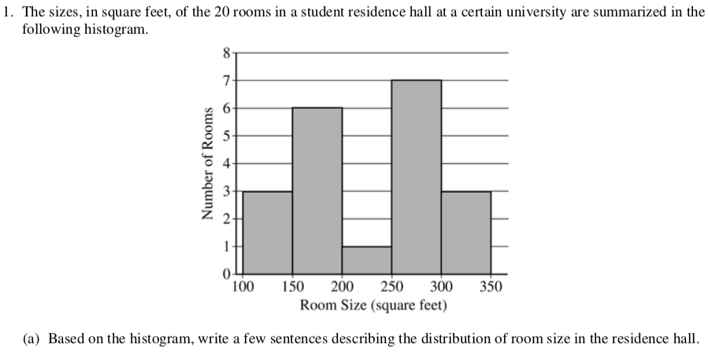

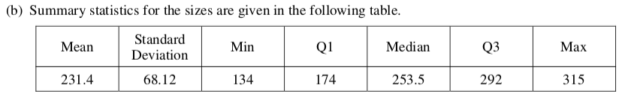
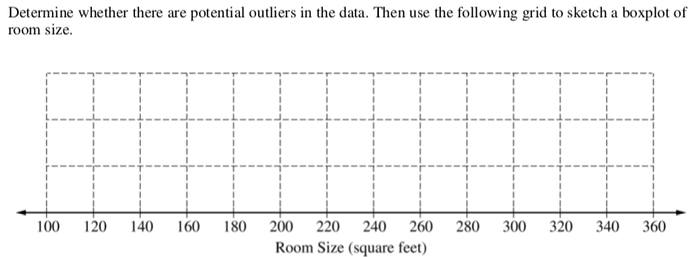

(c) What characteristic of the shape of the distribution of room size is apparent from the histogram but not from the boxplot?

2. Researchers are investigating the effectiveness of using a fungus to control the spread of an insect that destroys trees. The researchers will create four different concentrations of fungus mixtures: 0 milliliters per liter (ml/L), 1.25 ml/L, 2.5 ml/L, and 3.75 ml/L. An equal number of the insects will be placed into 20 individual containers. The group of insects in each container will be sprayed with one of the four mixtures, and the researchers will record the number of insects that are still alive in each container one week after spraying.
(a) Identify the treatments, experimental units, and response variable of the experiment.
Treatments:

Experimental units:

Response variable:

(b) Does the experiment have a control group? Explain your answer.

(c) Describe how the treatments can be randomly assigned to the experimental units so that each treatment has the same number of units.

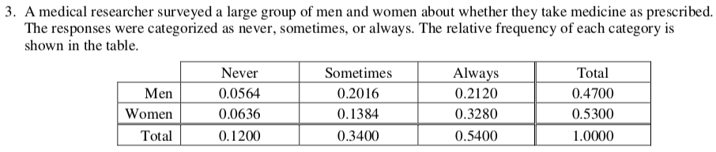
(a) One person from those surveyed will be selected at random.
(i) What is the probability that the person selected will be someone whose response is never and who is a woman?

(ii) What is the probability that the person selected will be someone whose response is never or who is a woman?

(iii) What is the probability that the person selected will be someone whose response is never given that the person is a woman?

(b) For the people surveyed, are the events of being a person whose response is never and being a woman independent? Justify your answer.

(c) Assume that, in a large population, the probability that a person will always take medicine as prescribed is 0.54. If 5 people are selected at random from the population, what is the probability that at least 4 of the people selected will always take medicine as prescribed? Support your answer.

4. Tumbleweed, commonly found in the western United States, is the dried structure of certain plants that are blown by the wind. Kochia, a type of plant that turns into tumbleweed at the end of the summer, is a problem for farmers because it takes nutrients away from soil that would otherwise go to more beneficial plants. Scientists are concerned that kochia plants are becoming resistant to the most commonly used herbicide, glyphosate. In 2014, 19.7 percent of 61 randomly selected kochia plants were resistant to glyphosate. In 2017, 38.5 percent of 52 randomly selected kochia plants were resistant to glyphosate. Do the data provide convincing statistical evidence, at the level of a = 0.05, that there has been an increase in the proportion of all kochia plants that are resistant to glyphosate?

5. A company that manufactures smartphones developed a new battery that has a longer life span than that of a traditional battery. From the date of purchase of a smartphone, the distribution of the life span of the new battery is approximately normal with mean 30 months and standard deviation 8 months. For the price of $50, the company offers a two-year warranty on the new battery for customers who purchase a smartphone. The warranty guarantees that the smartphone will be replaced at no cost to the customer if the battery no longer works within 24 months from the date of purchase.
(a) In how many months from the date of purchase is it expected that 25 percent of the batteries will no longer work? Justify your answer.

(b) Suppose one customer who purchases the warranty is selected at random. What is the probability that the customer selected will require a replacement within 24 months from the date of purchase because the battery no longer works?

(c) The company has a gain of $50 for each customer who purchases a warranty but does not require
a replacement. The company has a loss (negative gain) of $150 for each customer who purchases a warranty and does require a replacement. What is the expected value of the gain for the company for each warranty purchased?

6. Emma is moving to a large city and is investigating typical monthly rental prices of available one-bedroom apartments. She obtained a random sample of rental prices for 50 one-bedroom apartments taken from a Web site where people voluntarily list available apartments.
(a) Describe the population for which it is appropriate for Emma to generalize the results from her sample.

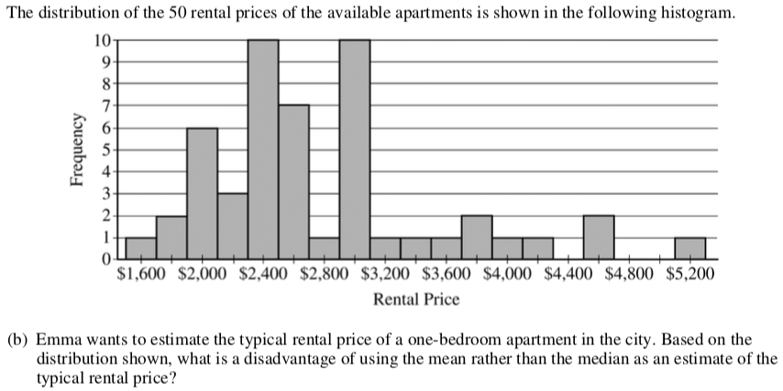

(c) Instead of using the sample median as the point estimate for the population median, Emma wants to use an interval estimate. However, computing an interval estimate requires knowing the sampling distribution
of the sample median for samples of size 50. Emma has one point, her sample median, in that sampling distribution. Using information about rental prices that are available on the Web site, describe how someone could develop a theoretical sampling distribution of the sample median for samples of size 50.

Because Emma does not have the resources to develop the theoretical sampling distribution, she estimates the sampling distribution of the sample median using a process called bootstrapping. In the bootstrapping process, a computer program performs the following steps.
- Take a random sample, with replacement, of size 50 from the original sample.
- Calculate and record the median of the sample.
- Repeat the process to obtain a total of 15,000 medians.
Emma ran the bootstrap process, and the following frequency table is the bootstrap distribution showing her results of generating 15,000 medians.
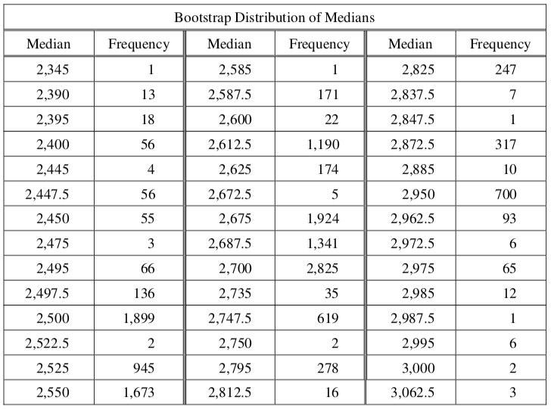

The bootstrap distribution provides an approximation of the sampling distribution of the sample median.
A confidence interval for the median can be constructed using a percentage of the values in the middle of the bootstrap distribution.
(d) Use the frequency table to find the following.
(i) Value of the 5th percentile:

(ii) Value of the 95th percentile:

(e) Find the percentage of bootstrap medians in the table that are equal to or between the values found in part (d).

(f) Use your values from parts (d) and (e) to construct and interpret a confidence interval for the median rental price.

